NON TEACHING STAFF
1 | Senior Assistant | MA | 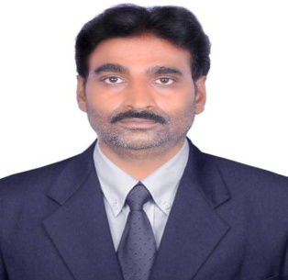
2 | Store Keeper | MA, MLISC
3 | Junior Assistant | 10+2 | 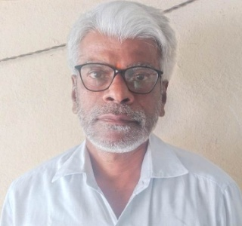
4 | Asst. Librarian |  | 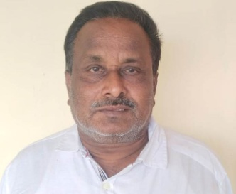
5 | Record Assistant | 10TH | 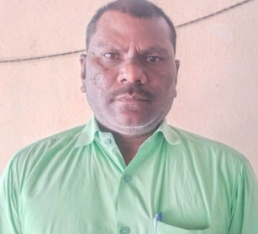
6 | Record Assistant |  | 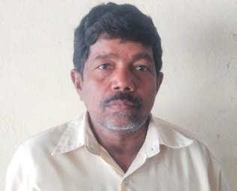
7 | Record Assistant | MA In TELUGU | 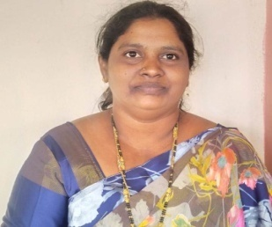
8 | Record Assistant |  | 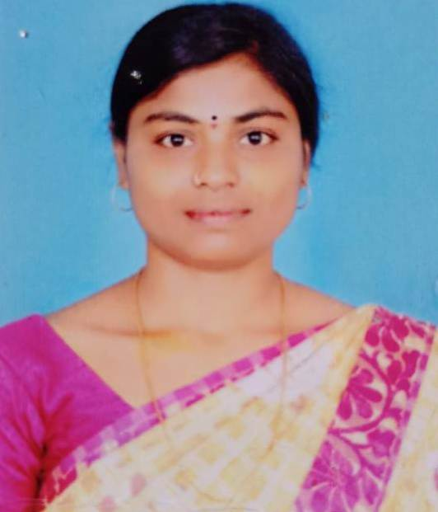
9 | Herbarium Keeper | 10TH | 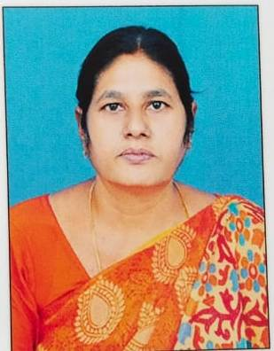
10 | Musium Keeper | 10TH | 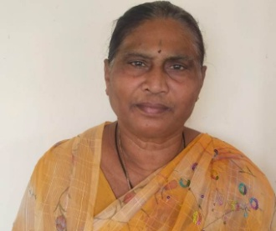
11 | Attender | B.A. | 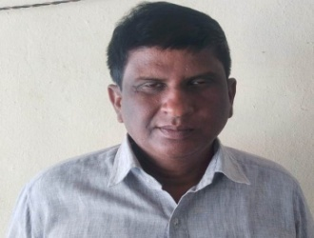
12 | Attender | B.A. | 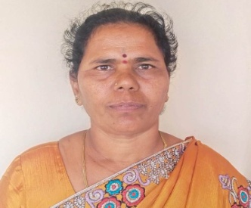
13 | Attender | 10TH | 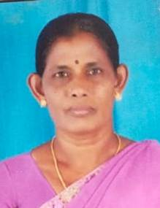
14 | Watchman |  | 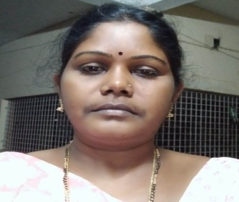
15 | Waterman | 10TH | 